**DTMF Based cell phone operated robot**

In this project the robot, is controlled by a mobile phone that makes call to the mobile phone attached to the robot in the course of the call, if any button is pressed for the control corresponding to the button pressed is heard at the other end of the call. This tone is called dual tone multi frequency (DTMF).

[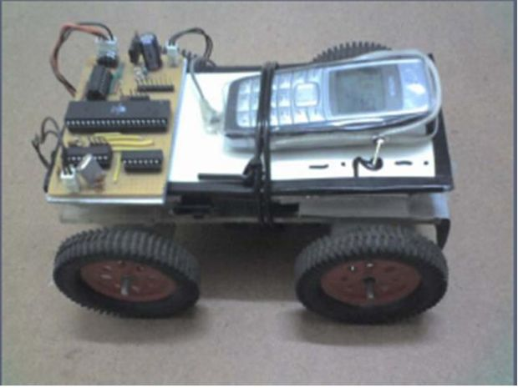](http://cdn.instructables.com/FZN/RPJE/FOD7QR9Q/FZNRPJEFOD7QR9Q.LARGE.jpg)

***INTRODUCTION:***

Robot receives this DTMF tone with the help of phone stacked in the robot. The received tone is processed by the atmel89S52 microcontroller with the help of DTMF decoder MT8870. The decoder decodes the DTMF tone in to its equivalent binary digit and this binary number is send to the microcontroller, the microcontroller is preprogrammed to take a decision for any given input and outputs its decision to motor drivers in order to drive the motors for forward or backward motion or a turn. The mobile that makes a call to the mobile phone stacked in the robot acts as a remote.

Conventionally, Wireless-controlled robots use RF circuits, which have the drawbacks of limited working range, limited frequency range and the limited control. Use of a mobile phone for robotic control can overcome these limitations. It provides the advantage of robust control, working range as large as the coverage area of the service provider, no interference with other controllers and up to twelve controls.   
Although the appearance and the capabilities of robots vary vastly, all robots share the feature of a mechanical, movable structure under some form of control. The Control of robot involves three distinct phases: perception, processing and action. Generally, the preceptors are sensors mounted on the robot, processing is done by the on-board microcontroller or processor, and the task is performed using motors or with some other actuators.

**Working:**

[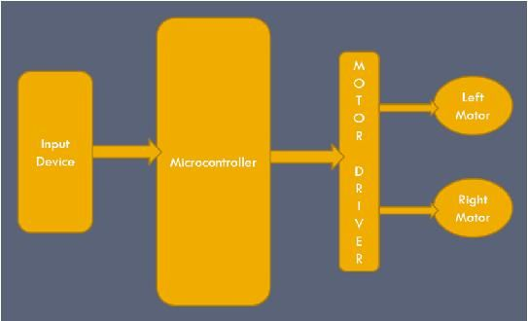](http://cdn.instructables.com/FB2/IGQ3/FOHTTHIT/FB2IGQ3FOHTTHIT.LARGE.jpg)

The tones and assignments in a DTMF system shown below

[[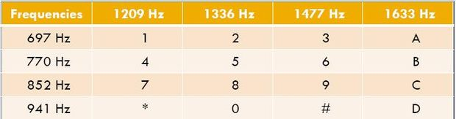](http://cdn.instructables.com/FS5/G8ON/FOHTTHJC/FS5G8ONFOHTTHJC.LARGE.jpg)](http://cdn.instructables.com/FS5/G8ON/FOHTTHJC/FS5G8ONFOHTTHJC.LARGE.jpg)

**PROJECT OVERVIEW**

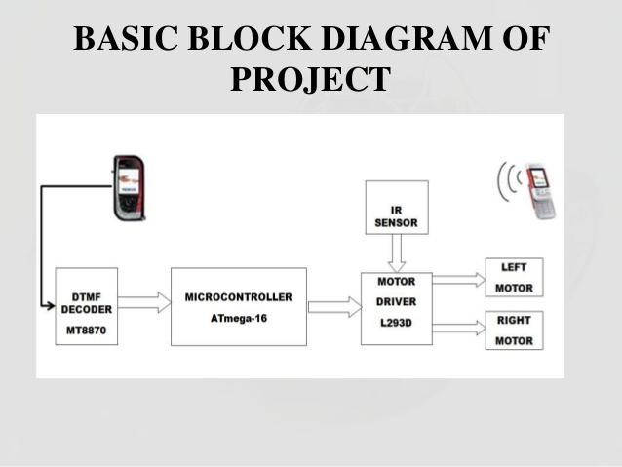

DTMF assigns a specific frequency (consisting of two separate tones) to each keys that it can easily be identified by the electronic circuit. The signal generated by the DTMF encoder is the direct algebraic submission, in real time of the amplitudes of two sine (cosine) waves of different frequencies, i.e., pressing 5 will send a tone made by adding 1336 Hz and 770 Hz to the other end of the mobile.

So this simple robotic project does not require the construction of receiver and transmitter units. DTMF signaling is used for telephone signaling over the line in the voice frequency band to the call switching center. The version of DTMF used for telephone dialing is known as touch tone.

